**Effects of UA on Survival Rate and Cholesterol Efflux Rate of RAW264.7 Macrophage-derived Foam Cells**

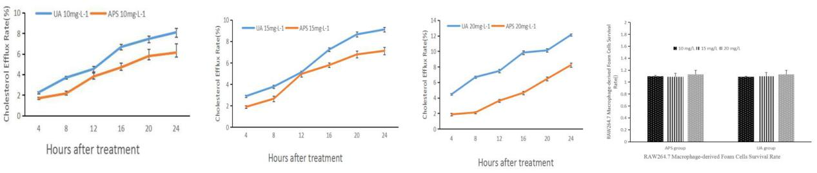

**Fig.1 Effects of UA on Survival Rate and Cholesterol Efflux Rate of RAW264.7 Macrophage-derived Foam Cells** (A) Comparison of the outflows of cholesterol in the UA 10 mg·L-1 group and the APS 10 mg·L-1 group；(B) Comparison of the outflows of cholesterol in the UA 15 mg·L-1 group and the APS 15 mg·L-1 group；(C) Comparison of the outflows of cholesterol in the UA 20 mg·L-1 group and the APS 20 mg·L-1 group；The results of Fig A, B and C show that the outflow rate of cholesterol in UA group was significantly higher than that in APS group, and the increase of APS group was not obvious；(D)The MTT assay was used to detect the survival rate of foam cells. The results showed that there was no significant difference in A570 nm between U and HBs in 15,20 mg·L-1 dose group and APS group（*P*＞0.05），the survival rate of RAW264.7 macrophages was not significantly affected by ursolic acid at 10, 15 and 20 mg·L-1.

|  |  |  |
| --- | --- | --- |
| Time | UA 10mg·L-1 | APS 10mg·L-1 |
| 4h | 2.12±0.07 | 1.76±0.05 |
| 8h | 3.87±0.12 | 2.02±0.12 |
| 12h | 4.34±0.26 | 3.43±0.24 |
| 16h | 6.42±0.32 | 4.24±0.37 |
| 20h | 7.23±0.36 | 5.26±0.32 |
| 24h | 7.89±0.67 | 5.78±0.58 |

Table 1. 10 mg·L-1 UA groupand APS groupCholesterol Efflux Rate

|  |  |  |
| --- | --- | --- |
| Time | UA 15mg·L-1 | APS 15mg·L-1 |
| 4h | 2.52±0.07 | 1.89±0.05 |
| 8h | 3.21±0.12 | 2.24±0.12 |
| 12h | 5.23±0.26 | 4.23±0.24 |
| 16h | 7.56±0.32 | 5.24±0.37 |
| 20h | 8.36±0.36 | 5.86±0.32 |
| 24h | 9.34±0.67 | 6.32±0.58 |

Table 2. 15 mg·L-1 UA groupand APS groupCholesterol Efflux Rate

|  |  |  |
| --- | --- | --- |
| Time | UA 20mg·L-1 | APS 20mg·L-1 |
| 4h | 4.46±0.11 | 1.87±0.16 |
| 8h | 6.67±0.13 | 2.12±0.14 |
| 12h | 7.47±0.21 | 3.64±0.19 |
| 16h | 9.84±0.26 | 4.65±0.21 |
| 20h | 10.12±0.21 | 6.46±0.23 |
| 24h | 12.13±0.15 | 8.24±0.27 |

Table 3. 20 mg·L-1 UA groupand APS groupCholesterol Efflux Rate

|  |  |  |  |
| --- | --- | --- | --- |
|  | 10 mg/L | 15 mg/L | 20 mg/L |
| APS group | 1.1±0.03 | 1.09±0.09 | 1.13±0.02 |
| UA group | 1.09±0.01 | 1.1±0.06 | 1.13±0.07 |

Table 4. RAW264.7 Macrophage-derived Foam Cells Survival Rate

**Effects of UA on Foam Cell Formation**

Compared with the blank group was dose-dependent, Oil red O staining indicating that ursolic acid can inhibit the formation of foam cells, promote lipid and cholesterol outflow.

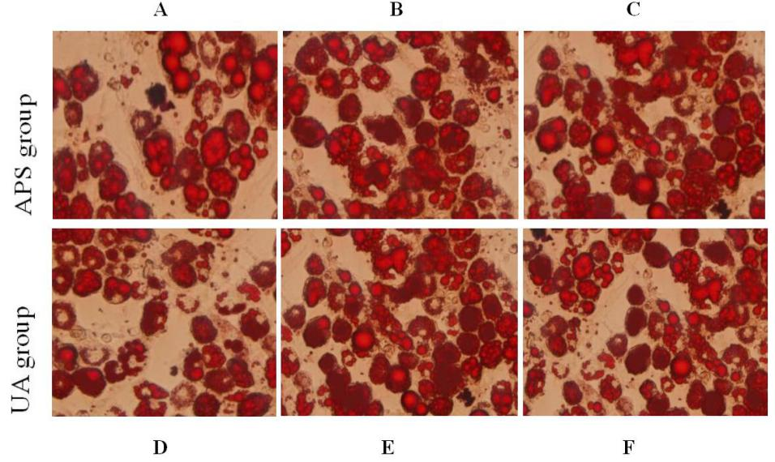

**Figure 2 Effects of UA on Foam Cell Formation** (A) Oil red O staining showed that APS 10 mg • L-1 group a small amount of cholesterol flows out of foam cells;(B) APS 15 mg • L-1 group The efflux of cholesterol in the foam cells was significantly higher than that of the A-curve;(C) APS 20 mg • L-1 group The efflux of cholesterol in foam cells was more obvious than that of figure A and B;(D) UA 10 mg • L-1 group a small amount of cholesterol flows out of foam cells，compared with the A map, cholesterol outflow increased significantly;(E) UA 15 mg • L-1 group cholesterol outflows in foam cells,compared with the figure A APS 15 mg • L-1 group, cholesterol outflow increased significantly;(F)UA 20 mg • L-1 group，compared with the figure A APS 20 mg • L-1 group, cholesterol outflow increased significantly;The results showed that the outflow of cholesterol in the UA group increased with the increase of UA dose. The efflux of cholesterol in APS group increased with the increase of dose. Compared with APS group, the cholesterol outflow of UA group increased significantly, indicating that UA promoted the foam Intracellular cholesterol efflux was more pronounced than the APS group.

**Effects of Ursolic Acid (UA) on SIRT1, PPARγ and ACAT-1 Gene Expression in Macrophage-derived Foam Cells**

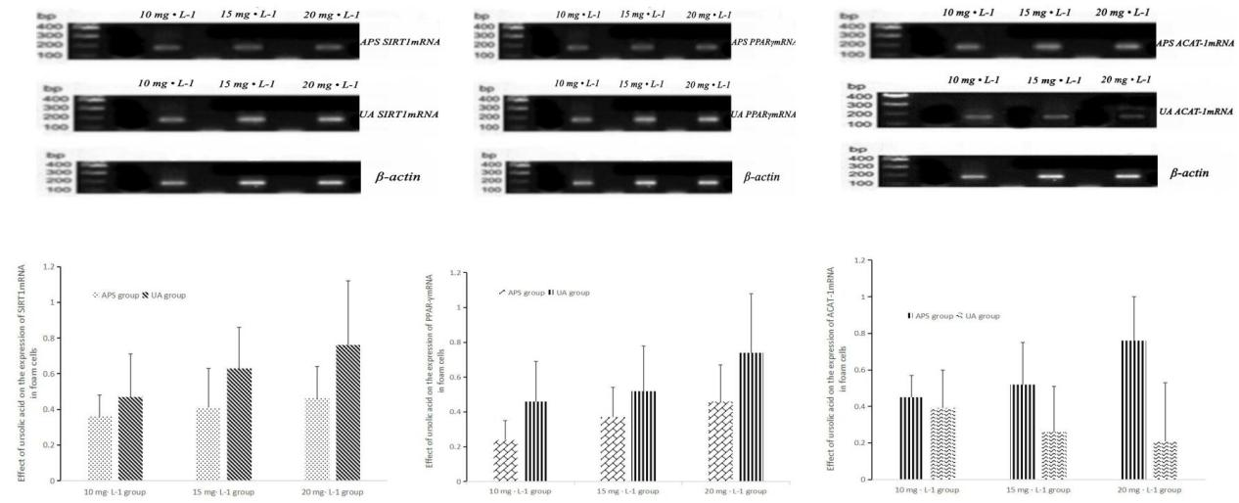

**Fig.３ Effects of Ursolic Acid (UA) on SIRT1, PPARγ and ACAT-1 Gene Expression in Macrophage-derived Foam Cells** 10mg•L-1, 15mg•L-1 and 20mg•L-1 APS were administered to the APS group at different concentrations of 10 mg•L-1, 15 mg•L-1 and 20 mg•L-1. The expression of SIRT1, PPARγ and ACAT-1 in the two groups was compared with that of the total RNA (DP419). The results showed that there was significant difference SIRT1, PPARγand ACAT-1 gene expression between the APS group and UA group.(A) Compared with APS group, the expression of SIRT1 gene in UA group increased significantly and increased with the increase of concentration;(B) Compared with APS group, the expression of PPARγ gene in UA group increased significantly and increased with the increase of concentration;(C)Compared with APS group, the expression of ACAT-1 gene in UA group increased significantly and increased with the increase of concentration.

|  |  |  |
| --- | --- | --- |
|  | APS group | UA group |
| 10 mg·L-1 group | 0.36±0.12 | 0.47±0.24 |
| 15 mg·L-1 group | 0.41±0.22 | 0.63±0.23 |
| 20 mg·L-1 group | 0.46±0.18 | 0.76±0.36 |

**Table 5.Effect of ursolic acid on the expression of SIRT1mRNA in foam cells**

|  |  |  |
| --- | --- | --- |
|  | APS group | UA group |
| 10 mg·L-1 group | 0.24±0.11 | 0.46±0.23 |
| 15 mg·L-1 group | 0.37±0.17 | 0.52±0.26 |
| 20 mg·L-1 group | 0.46±0.21 | 0.74±0.34 |

**Table 6.Effect of ursolic acid on the expression of PPAR-γmRNA in foam cells**

|  |  |  |
| --- | --- | --- |
|  | APS group | UA group |
| 10 mg·L-1 group | 0.24±0.11 | 0.46±0.23 |
| 15 mg·L-1 group | 0.37±0.17 | 0.52±0.26 |
| 20 mg·L-1 group | 0.46±0.21 | 0.74±0.34 |

**Table 7.Effect of ursolic acid on the expression of ACAT-1 mRNA in foam cells**

**Effects of Ursolic Acid (UA) on the Expression of SIRT1, PPARγ and ACAT-1 Proteins in Macrophage-derived Foam Cells**

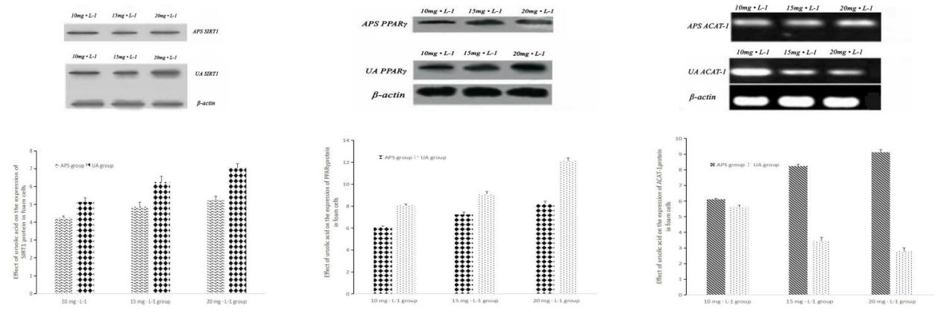

**Fig.4 Effects of Ursolic Acid (UA) on the Expression of SIRT1, PPARγ and ACAT-1 Proteins in Macrophage-derived Foam Cells** The expression of SIRT1, PPARγ and ACAT-1 protein was detected by Western blotting after adding 10mg•L-1, 15mg•L-1 and 20mg•L-1 UA to RAW264.7 macrophage-derived foam cells for 24 hours. The results showed that the expression of SIRT1 and PPARγ protein increased gradually with the increase of UA concentration, while the expression of ACAT-1 protein decreased gradually compared with 10mg•L-1, 15mg•L-1 and 20mg •L-1 APS group. (A) Compared with APS group, the expression of SIRT1 protein in UA group was significantly increased and increased with the increase of concentration;(B) Compared with APS group, the expression of SIRT1 protein in UA group was significantly increased and increased with the increase of concentration;(C) Compared with APS group, the expression of PPARγ protein in UA group was significantly increased and decreased with the increase of concentration.

|  |  |  |
| --- | --- | --- |
|  | APS group | UA group |
| 10 mg · L-1 group | 4.23±0.12 | 5.14±0.23 |
| 15 mg · L-1 group | 4.87±0.24 | 6.25±0.32 |
| 20 mg · L-1 group | 5.24±0.22 | 7.03±0.25 |

**Table 8. Effects of Ursolic Acid (UA) on the Expression of SIRT1Proteins in Macrophage-derived Foam Cells**

|  |  |  |
| --- | --- | --- |
|  | APS group | UA group |
| 10 mg · L-1 group | 6.12±0.07 | 8.09±0.12 |
| 15 mg · L-1 group | 7.24±0.23 | 9.11±0.24 |
| 20 mg · L-1 group | 8.26±0.21 | 12.13±0.27 |

**Table 9. Effects of Ursolic Acid (UA) on the Expression of PPARγ Proteins in Macrophage-derived Foam Cells**

|  |  |  |
| --- | --- | --- |
|  | APS group | UA group |
| 10 mg · L-1 group | 6.12±0.06 | 5.63±0.11 |
| 15 mg · L-1 group | 8.24±0.12 | 3.45±0.23 |
| 20 mg · L-1 group | 9.12±0.17 | 2.78±0.24 |

**Table 10. Effects of Ursolic Acid (UA) on the Expression of ACAT-1 Proteins in Macrophage-derived Foam Cells**

Oct. 4, 2017